Do Children Diagnose with Major Depressive Disorder Exhibit Impaired Cognitive Functioning?

Philomena B. Ned
Prairie View A&M University
PSYC 4843Z02
Dr. Columb

Study 2
Introduction
Depression has affected approximately 2% of pre-school and school-age children, with significant causes being biological, psychological, or environmental. Risks of depression: individual (difficult temperament, low self-esteem, low positive mood); family (conflict, level of expressed emotion, parenting style, maternal depression); peer and school (peer rejection, aggression); and socioeconomic (poverty, stressful life events). Reinherz and colleagues (1999) investigated the effects of depression in women and men aged 18-21 years. Results showed that cognitive impairment induced by depression contributes to the impaired transition from childhood to adulthood.
In a test conducted by (Kovacs & Goldston, 1991) in the American school of psychology, results indicated that children who had been diagnosed with depression at a point in their lives showed impairment in certain social domains such as schoolwork and ability to socialize. The depressed children also showed a decline in vocal performance after consecutive tests (Kovacs & Goldston, 1991). In a study conducted by Lepisto and colleagues (2004), results showed that depressed children had shorter mismatch negativity and late discriminative negativity latencies than the controls, who constituted children who had no history of depression.
A 2014 meta-analysis established that people with depression have difficulties with attention and memory and struggled to execute a function (Kizilbash & Vanderploeg, Curtiss, G. 2002). The research by (Kizilbash & Vanderploeg, Curtiss, G. 2002) also showed that poor performance in children with depression was associated with the slow acquisition of knowledge and difficulty retaining it. Another study showed that children with depression were less likely to remember answers they had replied fittingly than non-depressed children precisely. The depressed children also recalled a few of their correct answers and performed poorly in identifying the investigator's correct answers (Whitman & Leitenberg, 1990). A study by Olive and colleagues (2019) confirmed that depression causes brain distortion and leads to attention bias, explaining why depressed children were more likely to identify negative stimuli while they block out positive impulses. Although Study 1 did not show a correlation between depression and cognitive functioning I hope to find a correlation in Study 2.
Research Hypothesis
Children diagnosed with Major depressive Disorder will exhibit significantly impaired cognitive functioning compared to children that are not diagnosed with major depression.
Method
Participants
The participants will include children (N=500) from ages 7-16 years old. Minors must be at least seven years of age to participate in cognitive functioning tests. The children will be randomly selected from both public and private outreach centers that focus on children with major depressive disorders within the USA. The targeted study population is expected to be (N=500) minors with 50% male and 50% female with a mean score of M=12 and a standard deviation of SD=3.20. To eradicate the gender bias issue within the study, we want to ensure the genders are balanced in number. Race is not a considered factor in this study.
Random children will be approached and given a brief description of the experiment; if they chose to participate, the tester would then give them a parental consent form to take home for their parents to sign. Each child that participates in this study will be given a $20 Gift Card from Game Stop. Selected participants will be required to have had a current diagnosis of major depressive disorder and have obtained recent scores indicating moderate to severe depression on a screening questionnaire.
Subjects will be excluded in the cases where they had a self-reported comorbid psychiatric diagnosis or a current or previous history of a neurological condition. Children with pre-existing conditions such as Autism, Multiple Sclerosis, ADHD, and any other learning disabilities will also be excluded. The exclusion is because the pre-existing condition makes it difficult to determine if depression is an underlying condition. Children with Autism will be excluded because, generally, Autistic children have the minimal cognitive ability and may even be nonverbal. Some may even suffer from Nystagmus, which is involuntary eye movement. They may experience difficulties focusing due to their poor sight. Nystagmus is not limited to children with Autism.
Procedure
The number that was randomly selected 1, 2, or 3 will be the Group number the participant will be placed in for treatment. Once all parental consents have been signed by the parent and turned in to us, we will begin the study. Parents will also be required to sign a release of information for testers to obtain medical records. Each child will be given The Integrated Visual and Auditory version 2 (IVA-2), which the testers will use to assess visual and auditory attention and response control. It will rule out ADHD. The IVA-2 will take 15 minutes to complete. The testers will use a random selection app on an iPhone that will randomly choose a number 1, 2, or 3.
Each number will represent the group that the child will be placed in for testing. The children's parents will be given a Child Behavioral Checklist (CBCL) to help us assess any of the child’s behavioral problems. This assessment takes 5 to 10 minutes to complete. Parents will also be required to sign a release of information for testers to obtain medical records. The population will be divided into smaller group numbers then written down after being randomly selected and recorded on an Excel Spreadsheet.
All participants with a random number of 1 will be referenced as Group 1. Group 1 will participate in a clinical interview where a Mental Status Exam with be administered to measure cognitive functioning. This group will be administered the Children’s Depression Inventory (CDI) it assesses the depression severity in children, takes about 15 minutes to administer. Once the scoring is completed, we will move on to the next assessment. Center for Epidemiologic Studies Depression Scale (CES-D) which measures depression experienced within the last 7 days. While the participants are completing the assessments, the testers will look for facial expressions, fidgeting, and lack of interest in the assessment. Once these assessments are completed Group 2 will be giving a Posttest Survey. The questionnaire consisted of thirty questions within the 5-point Likert Scale. The questions will measure their levels of depression with a range of one to five from Strongly Disagree, Disagree, Neutral, Agree, and Strongly Agree.
Group 2 will be composed of the participants that received the number 2 in the random number app. Once all parental consents have been signed by the parent and turned in to us, we will begin the study. Parents will also be required to sign a release of information for testers to obtain medical records. The participants will be given an exercise called “All About Me” where they can write or draw their favorite things. While the participants are completing the assessments, the testers will look for facial expressions, fidgeting, and lack of interest in the assessment. Once the exercise is completed, Group 2 will be giving a Posttest Survey. The questionnaire consisted of thirty questions within the 5-point Likert Scale. The questions will determine their level of focusing with a range of one to five from Very Unlikely, Unlikely, Neutral, Likely, and Very Likely.
Group 3 will be composed of the participants that received the number 3 in the random number app. Once all parental consents have been signed by the parent and turned in to us, we will begin the study. Parents will also be required to sign a release of information for testers to obtain medical records. The testers will not give Group 3 any treatment; however, they will have to complete a Post Test Survey. The questionnaire consisted of thirty questions within the 5-point Likert Scale. The first fifteen questions will measure their levels of depression with a range of one to five from Strongly Disagree, Disagree, Neutral, Agree, and Strongly Agree. The last fifteen questions will determine their level of focusing with a range of one to five from Very Unlikely, Unlikely, Neutral, Likely, and Very Likely. While the participants are completing the questionnaire, the testers will look for facial expressions, fidgeting, and lack of interest.
Materials
The materials that will be used in Study 2 are the Mental Status Exam, administer formal tests such as the IVA-2 (auditory and visual concentration), Children's Depression Inventory (CDI) which assesses the depression severity in children; Center for Epidemiologic Studies Depression Scale (CES-D) measures depression experienced within the last seven days. The children's parents will be given a Child Behavioral Checklist (CBCL) to help us assess any of the child’s behavioral problems. Lastly, I will be administering an activity called, “All About Me” that allows the children to write out and draw out their favorite things to do.
Results
The study results are expected to show a strong positive correlation between depression and the occurrence of cognitive function impairment. This study's research approach was a quasi-experiment designed to establish the cause-and-effect relationship between cognitive functioning and significant depression. Sample size (N=500) and sample selection is the most critical part of any study. Small sample size may not be representative of the findings. A significantly large sample size increases the number of significant outliers. Ideally, data will be entered, sorted, and analyzed using the Statistical Package for Social Sciences (SPSS). Of the 500 participants, approximately 300 participants are expected to participate due to exclusions.
The results are expected to confirm the hypothesis that children diagnosed with depression exhibit impaired cognitive functioning. Of the 300 diagnosed patients, a large percentage, approximately 70%, are likely to exhibit poor cognitive functioning by showing poor performance in class and poor ability to perform well in social functions. The independent variable is cognitive functioning which consists of memory, attention, processing speed, problem-solving, and multi-tasking. Since the study aims at establishing the relationship between cognitive function and depression, cross-tabulation using ANOVA test will be used to establish the association. The Dependent Variable is “I am depressed.”
Discussion
Depression has been a significant contributor to the global burden of disease as it affects around 300 million people globally and often results in disability (Broder, M. 2021). Kovacs, M., and colleagues (1991) indicated in their evidence-based study showed that depression rendered many children impaired in various cognitive and social domains, affecting actual school performance by lowering intellectual abilities. Since depression affects attention, children diagnosed with depression were more likely to perform poorly in school and general life situations (Blanken et al., 2016). Therefore, the study's results are expected to be in line with the previously conducted research that showed that cognitive impairment was related to depression.
There are, however, expected limitations to the study in that there could be other factors contributing to the cognitive impairment, primarily since the study will deal with children, most of whose problems might not have been identified before the onset of the study. Covariants, such as fetal alcohol syndrome, drugs, demographics leading to lower knowledge in different topics, lack of exposure, and other factors, could cause invalidity of this study.
The study participants, despite their difference in ages, will also be assessed using the same data. This factor could lead to alterations in the outcomes due to lack of exposure. The accessibility to the study participants where Outreach centers are mainly open in the afternoon when school is released. It might help the outcome if we could test them before school when the children are less tired. Children have not been exposed to the same level of responsibilities that adults have in life. It is much easier for an adult to find an alternate way to accomplish things in a depressed mood than it is for children. Therefore, I wanted my study to reflect depression causing cognitive functioning impairments.

Figure 1
Graph of depression and cognitive functioning in children
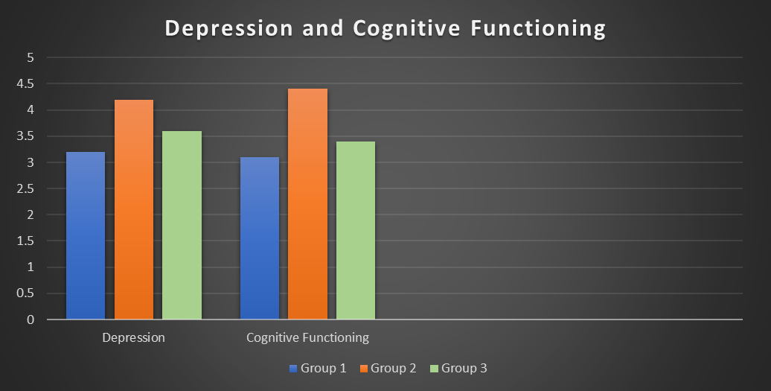
Note. Each bar corresponds to the treatment group for each variable.

References
Blanken, L., White, T., Mous, S., Basten, M., et al., (2016, September 19). Cognitive functioning
in children with internalizing, externalizing and dysregulation problems: A population-based study. Retrieved April 13, 2021, from https://link.springer.com/article/10.1007/s00787-016-0903-9
Broder, M. (2021). When cognitive dysfunction follows major depressive episodes. (2019, November 25). Retrieved April 13, 2021, from https://www.medpagetoday.com/resource-centers/mental-health-focus/cognitive-dysfunction-follows-major-depressive-episodes/2694
Keller, A. S., Leikauf, J. E., Holt-Gosselin, B., Staveland, B. R., & Williams, L. M. (2019). Paying attention to attention in depression. Translational Psychiatry, 9(1). doi:10.1038/s41398-019-0616-1
Kizilbash, A. H., Vanderploeg, R. D., & Curtiss, G. (2002). The effects of depression and anxiety on memory performance. Archives of Clinical Neuropsychology, 17(1), 57-67. doi:10.1093/arclin/17.1.57
Kovacs, M., & Goldston, D. (1991). Cognitive and social-cognitive development of depressed children and adolescents. Journal of the American Academy of Child & Adolescent Psychiatry, 30(3), 388-392. doi:10.1097/00004583-199105000-00006
Lepisto, T., Soininen, M., Ceponien, R., Almqvist, F., Naatanen, R., & Aronen, E. (2004). Auditory event-related potential indices of increased distractibility in children with major depression. Clinical Neurophysiology, 115(3), 620-627. doi:10.1016/j.clinph.2003.10.020
Oliver, A., Pile, V., Elm, D., & Lau, J. Y. (2019). The cognitive neuropsychology of depression in adolescents. Current Behavioral Neuroscience Reports, 6(4), 227-235. doi:10.1007/s40473-019-00187-0
Reinherz, H. Z., Giaconia, R. M., Hauf, A. M. C., Wasserman, M. S., & Silverman, A. B.
(1999). Major depression in the transition to adulthood: risks and impairments.
Journal of abnormal psychology, 108(3), 500. doi:10.1037/0021-843x.108.3.500
Whitman, P. B., & Leitenberg, H. (1990). Negatively biased recall in children with self-reported symptoms of depression. Journal of Abnormal Child Psychology, 18(1), 15-27. doi:10.1007/bf00919453

